PIZZA SALES SQL QUERIES
- KPI’S
1. Total Revenue
select sum(total_price) as Total_Revenue from Pizza_sales
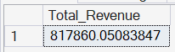
2. Average Order Value:
select sum(total_price) / count(distinct order_id) as Avg_Order_Value from Pizza_sales
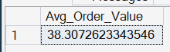
3.Total Pizzas sold:
select sum(quantity) as Total_pizzas_Sold from Pizza_sales
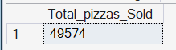
4. Total Orders:
select count(distinct order_id) as Total_orders from Pizza_sales
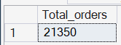
5. Average Pizzas per Order:
select cast( cast(sum(quantity) as decimal(10,2)) / cast(count( distinct order_id) as decimal(10,2)) as decimal(10,2)) as Avg_Pizzas_per_Order from Pizza_sales
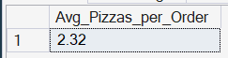
- CHARTS REQUIREMENTS
1.Daily Trend for Total Orders:
select datename(DW, order_date) as Order_day,count (distinct order_id) as Total_Orders from Pizza_sales group by datename(DW,order_date)
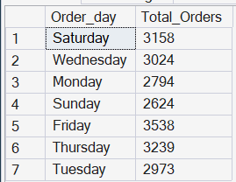
2.Monthly Trend for Total Orders:
SELECT DATENAME(MONTH, order_date) as Month_Name,count(distinct order_id) as Total_Orders from Pizza_sales group by DATENAME(MONTH, order_date) order by Total_Orders Desc
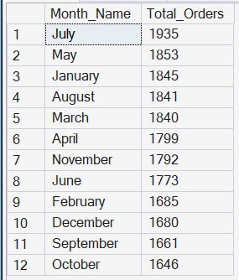
3.Percentage of Sales by Pizza Category:
SELECT pizza_category,sum(total_price) as Total_Sales, sum(total_price) * 100 / (SELECT sum(total_price) from Pizza_sales WHERE MONTH(order_date) = 1) as PCT from Pizza_sales WHERE MONTH(order_date) = 1 GROUP BY pizza_category
NOTE: We are calculating percentage for January
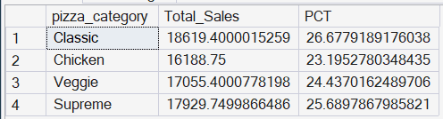

4. Percentage of Sales by Pizza Size:
SELECT pizza_size,cast(sum(total_price) as decimal(10,2))as Total_Sales, cast(sum(total_price) * 100 / (SELECT sum(total_price) from Pizza_sales where Datepart(quarter, order_date)=1)as decimal(10,2)) as PCT from Pizza_sales where Datepart(quarter, order_date)=1 GROUP BY pizza_size ORDER BY PCT DESC
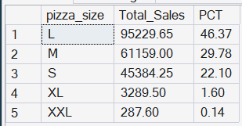
5.Total Pizzas Sold by Pizza Cateory:
SELECT pizza_category, SUM(quantity) AS Total_Pizzas_Sold FROM Pizza_sales GROUP BY pizza_category ORDER BY Total_Pizzas_Sold DESC;
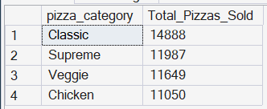
6. Top 5 Pizzas by Revenue:
SELECT TOP 5 pizza_name, SUM(total_price) as Total_Revenue from Pizza_sales GROUP BY pizza_name ORDER by Total_Revenue DESC
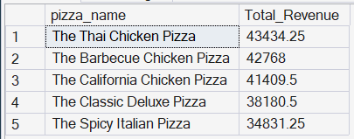
7. Bottom 5 Pizzas by Revenue:
SELECT TOP 5 pizza_name, SUM(total_price) as Total_Revenue from Pizza_sales GROUP BY pizza_name ORDER by Total_Revenue ASC

